Service Manager

This PowerShell script will start, stop and validate specified services.

To use the script you need to start the ServicesManager.PS1 script. This will launch a GUI

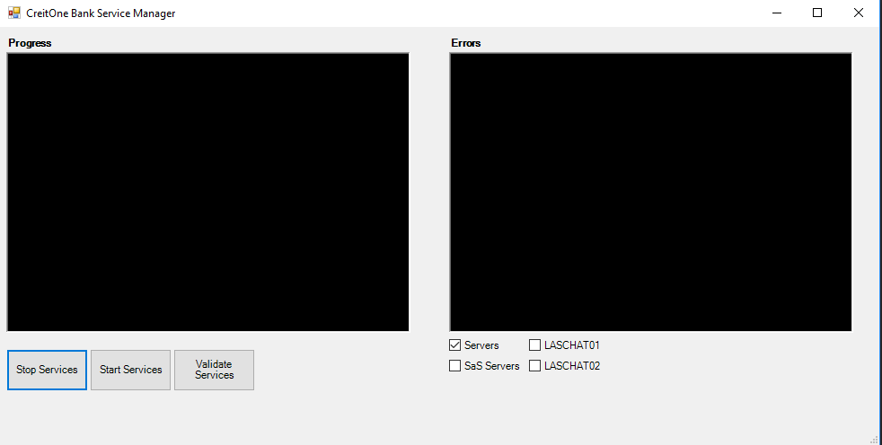

This new GUI looks similar to the old one but is not the same, you will notice that there are no longer tabs along the top, you now just need to select the check box for the server set you want to work with.

All servers other than Chat and SaS are covered under the “Server” check box. Simply select the servers you want to work with and click the Start/stop or validate buttons and Errors will show up on the right side text box everything else will show up on the left.

Servers and services are no longer hard coded directly into the script. This is now managed by text and CSV files. You will find Servers.CSV in the folder with the script. In this file you will see a list of all the servers and next to each server is the name of a text file that contains the services for that server class.

If you need to remove a server or add a server simply edit this file. If you need to modify the services that are changed you would modify the text file for that server class. If you want to add a new server class to the list simply create the text file with the services that you will need to work with and then add the servers to the CSV file. There is a CSV file for each check box.